Name:___________________________________ Date:________
Vocab and Zeros
*Can complete along with Desmos or after as a review

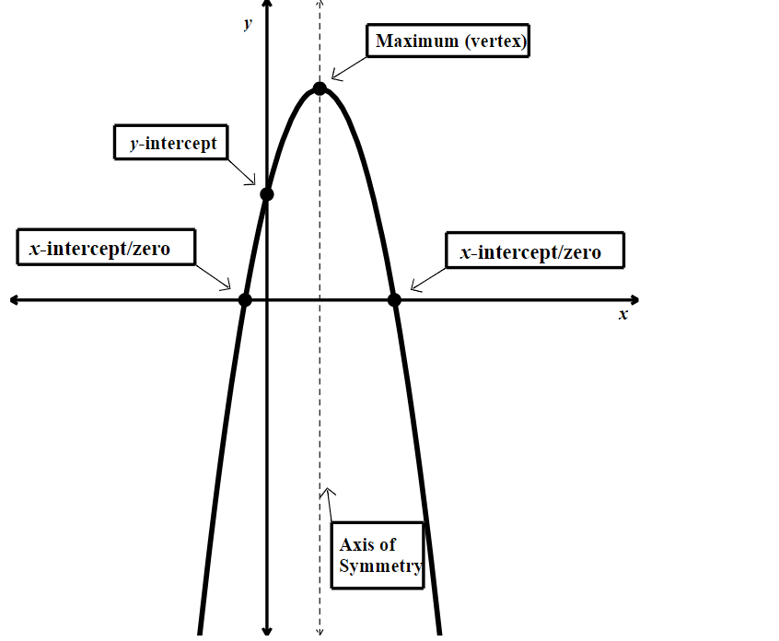

Definitions
Vertex:

Zeros/Solutions:

Y-intercept:

Axis of Symmetry:

Maximum:

Minimum:

