Unit D Exam Name: _____________

Circle the best answer.

1. Classify  and 

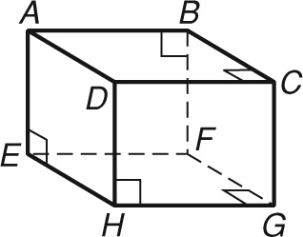

A skew segments

B parallel segments

C perpendicular segments

D intersecting segments

2. Classify  and 

A skew segments

B parallel segments

C perpendicular segments

D parallel planes

3. Which are NOT alternate interior angles?

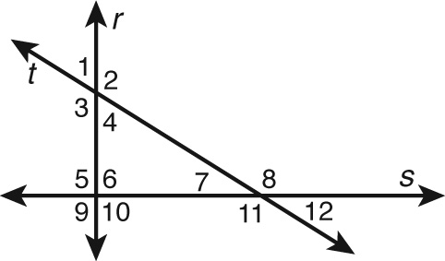

A 3 and 6 C 2 and 3

B 2 and 7 D 4 and 5

4. The angles formed by two lines and a transversal are labeled 1 through 8. If 1 and 8 are alternate interior angles and 1 and 5 are vertical angles, what type of angle pair is 5 and 8?

F alternate exterior angles

G corresponding angles

H alternate interior angles

J same-side interior angles

5. Which correctly completes the sentence? When two lines are parallel, the acute angles they form with a transversal are ________ to the obtuse angles.

A supplementary

B complementary

C congruent

D vertical

Use the figure for Exercises 6 and 7.

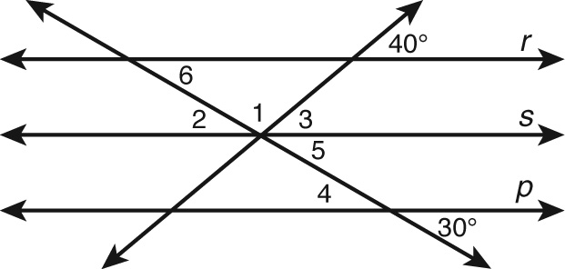

6. Given r || s  p, which angle is NOT   
congruent to 4?

F 2 H 5

G 3 J 6

7. Given r  s  p, what is the measure of 1?

A 40° C 110°

B 90° D 140°

8. Which CANNOT be used to prove that lines m and n are parallel?

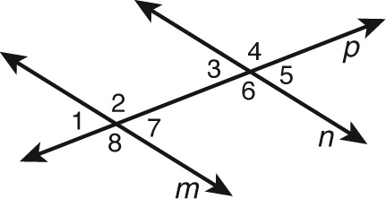

F 2  4

G 4 is supplementary to 7.

H 4 is supplementary to 5.

J 1  5

9. Lines r and s are cut by a transversal so that 1 and 2 are same-side interior angles.

If m1  (8x  40)° and m2  (12x  20)°, for what value of x is it true that r  s?

A 6 C 30

B 10 D 60

10. If a transversal is perpendicular to one of two parallel lines, which statement is NOT correct?

F All the angles formed are congruent.

G Every pair of angles is supplementary.

H The transversal is ⊥ to the other line.

J Every pair of angles is complementary.

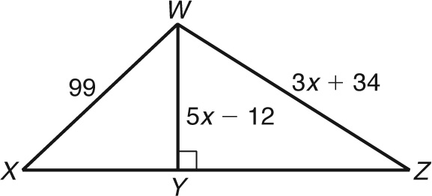 11. Which is a possible value of x?

A 21 C 25

B 23 D 26

12. Use the figure and the partially completed proof to fill in the missing blanks.

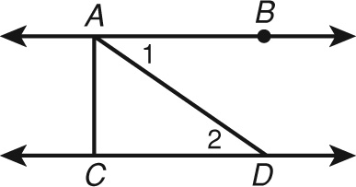

Given:  is the shortest segment from A to  and m1  m2.

Prove: 

Proof:

|  |  |
| --- | --- |
| **Statements** | **Reasons** |
| 1. m1  m2 | 1. Given |
| 2. ______ | 2. Given |
| 3. | 3. Distance from a point to a line |
| 4. | 4. Conv. of Alternate Int.  Thm. |
| 5. | 5.   _ ___________ |

13. Which is the equation of the line shown in the graph?

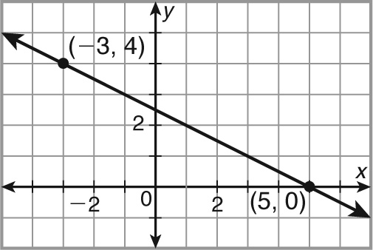

F  H 

G  J 

14. Given  what is the value of x?

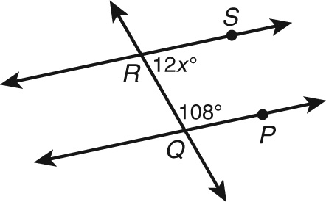

A 6 C 72

B 9 D 108

15. Given the point J(2, 4), for which point K is  a line with undefined slope?

F K(2, 4) H K(4, 2)

G K(2, 4) J K(2, 4)

16. Find the measure of FDE.

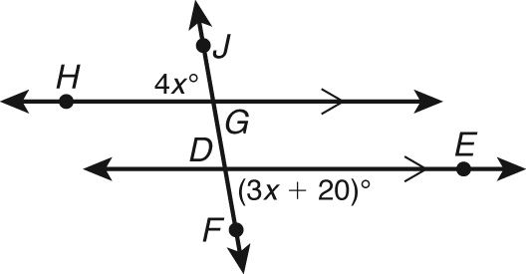

17. Given points A(1, 4), B(0, 4), C(2, 0), and D(2, 5), what type of lines are  and ?

F parallel H horizontal

G perpendicular J vertical

18. Which is an equation of a horizontal line?

A x  3 C y  x

B y  4 D y  x

19. Which is the equation of a line that does NOT go through the origin?

F x  0 H y  x

G y  x  1 J y  2x

20. Which line is NOT parallel to ?

A 2x  3y  6 C 6y  12  4x

B  D 4x  6y  12

21. Which line coincides with y = 4x + 2?

F y = 4x − 2 H y = −4x + 2

G 4y = x + 8 J 8x − 2y = −4

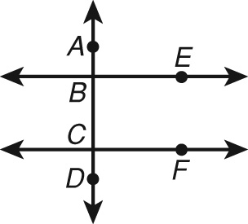**Bonus Questions:**

**#1**

Given:  and BCF  FCD.

Prove: 

Proof:

|  |  |
| --- | --- |
| **Statements** | **Reasons** |
| 1. | 1. Given |
| 2. BCF  FCD | 2. Given |
| 3. | 3.       ? |
| 4. | 4.       ? |

**#2** Which values for x and y make lines r, s, and t parallel?

