Geometry Note Sheet Date: _____________________
Definitions:
- Conjecture: ____________________________________________________________________

______________________________________________________________________________

- Point: _________________________________________________________________________

______________________________________________________________________________

- Line Segment: __________________________________________________________________

______________________________________________________________________________

- Line: _________________________________________________________________________

______________________________________________________________________________

- Parallel: _______________________________________________________________________

______________________________________________________________________________

- Perpendicular: _________________________________________________________________

______________________________________________________________________________

- Circle: ________________________________________________________________________

______________________________________________________________________________

- Radius: ________________________________________________________________________

______________________________________________________________________________

- Midpoint: ______________________________________________________________________

______________________________________________________________________________

- Perpendicular Bisector: ___________________________________________________________

______________________________________________________________________________

- Congruent: _____________________________________________________________________

______________________________________________________________________________

- Right Angle: ____________________________________________________________________

- Name each radius in the circle shown:
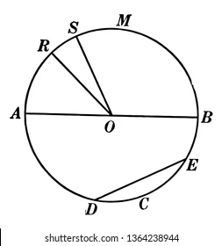

- Draw two LINES one labeled line MA and one labeled line TH and show them intersecting at the midpoint “X”.

