Name: ______________________
E1b – Classwork
- Re-write the following flowchart proof as a two-column proof:
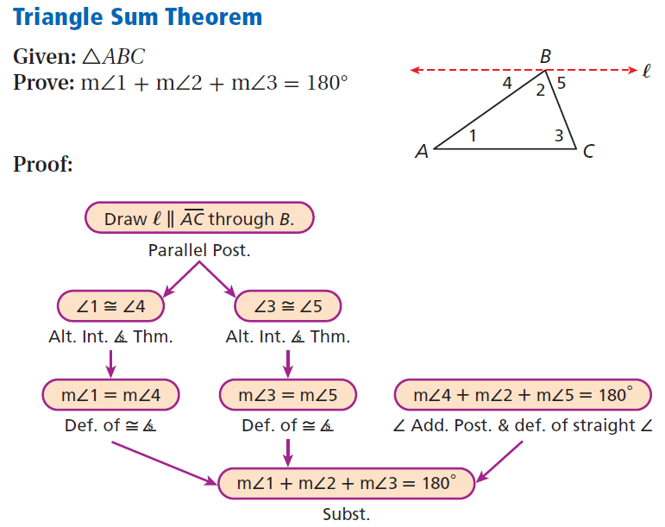
Given:
Prove:
Statements | Reasons

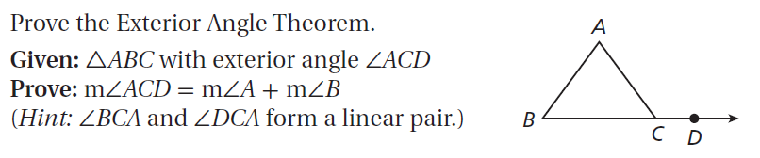

Statements | Reasons
