Geometry Note Sheet DAY 6 Date: _____________________
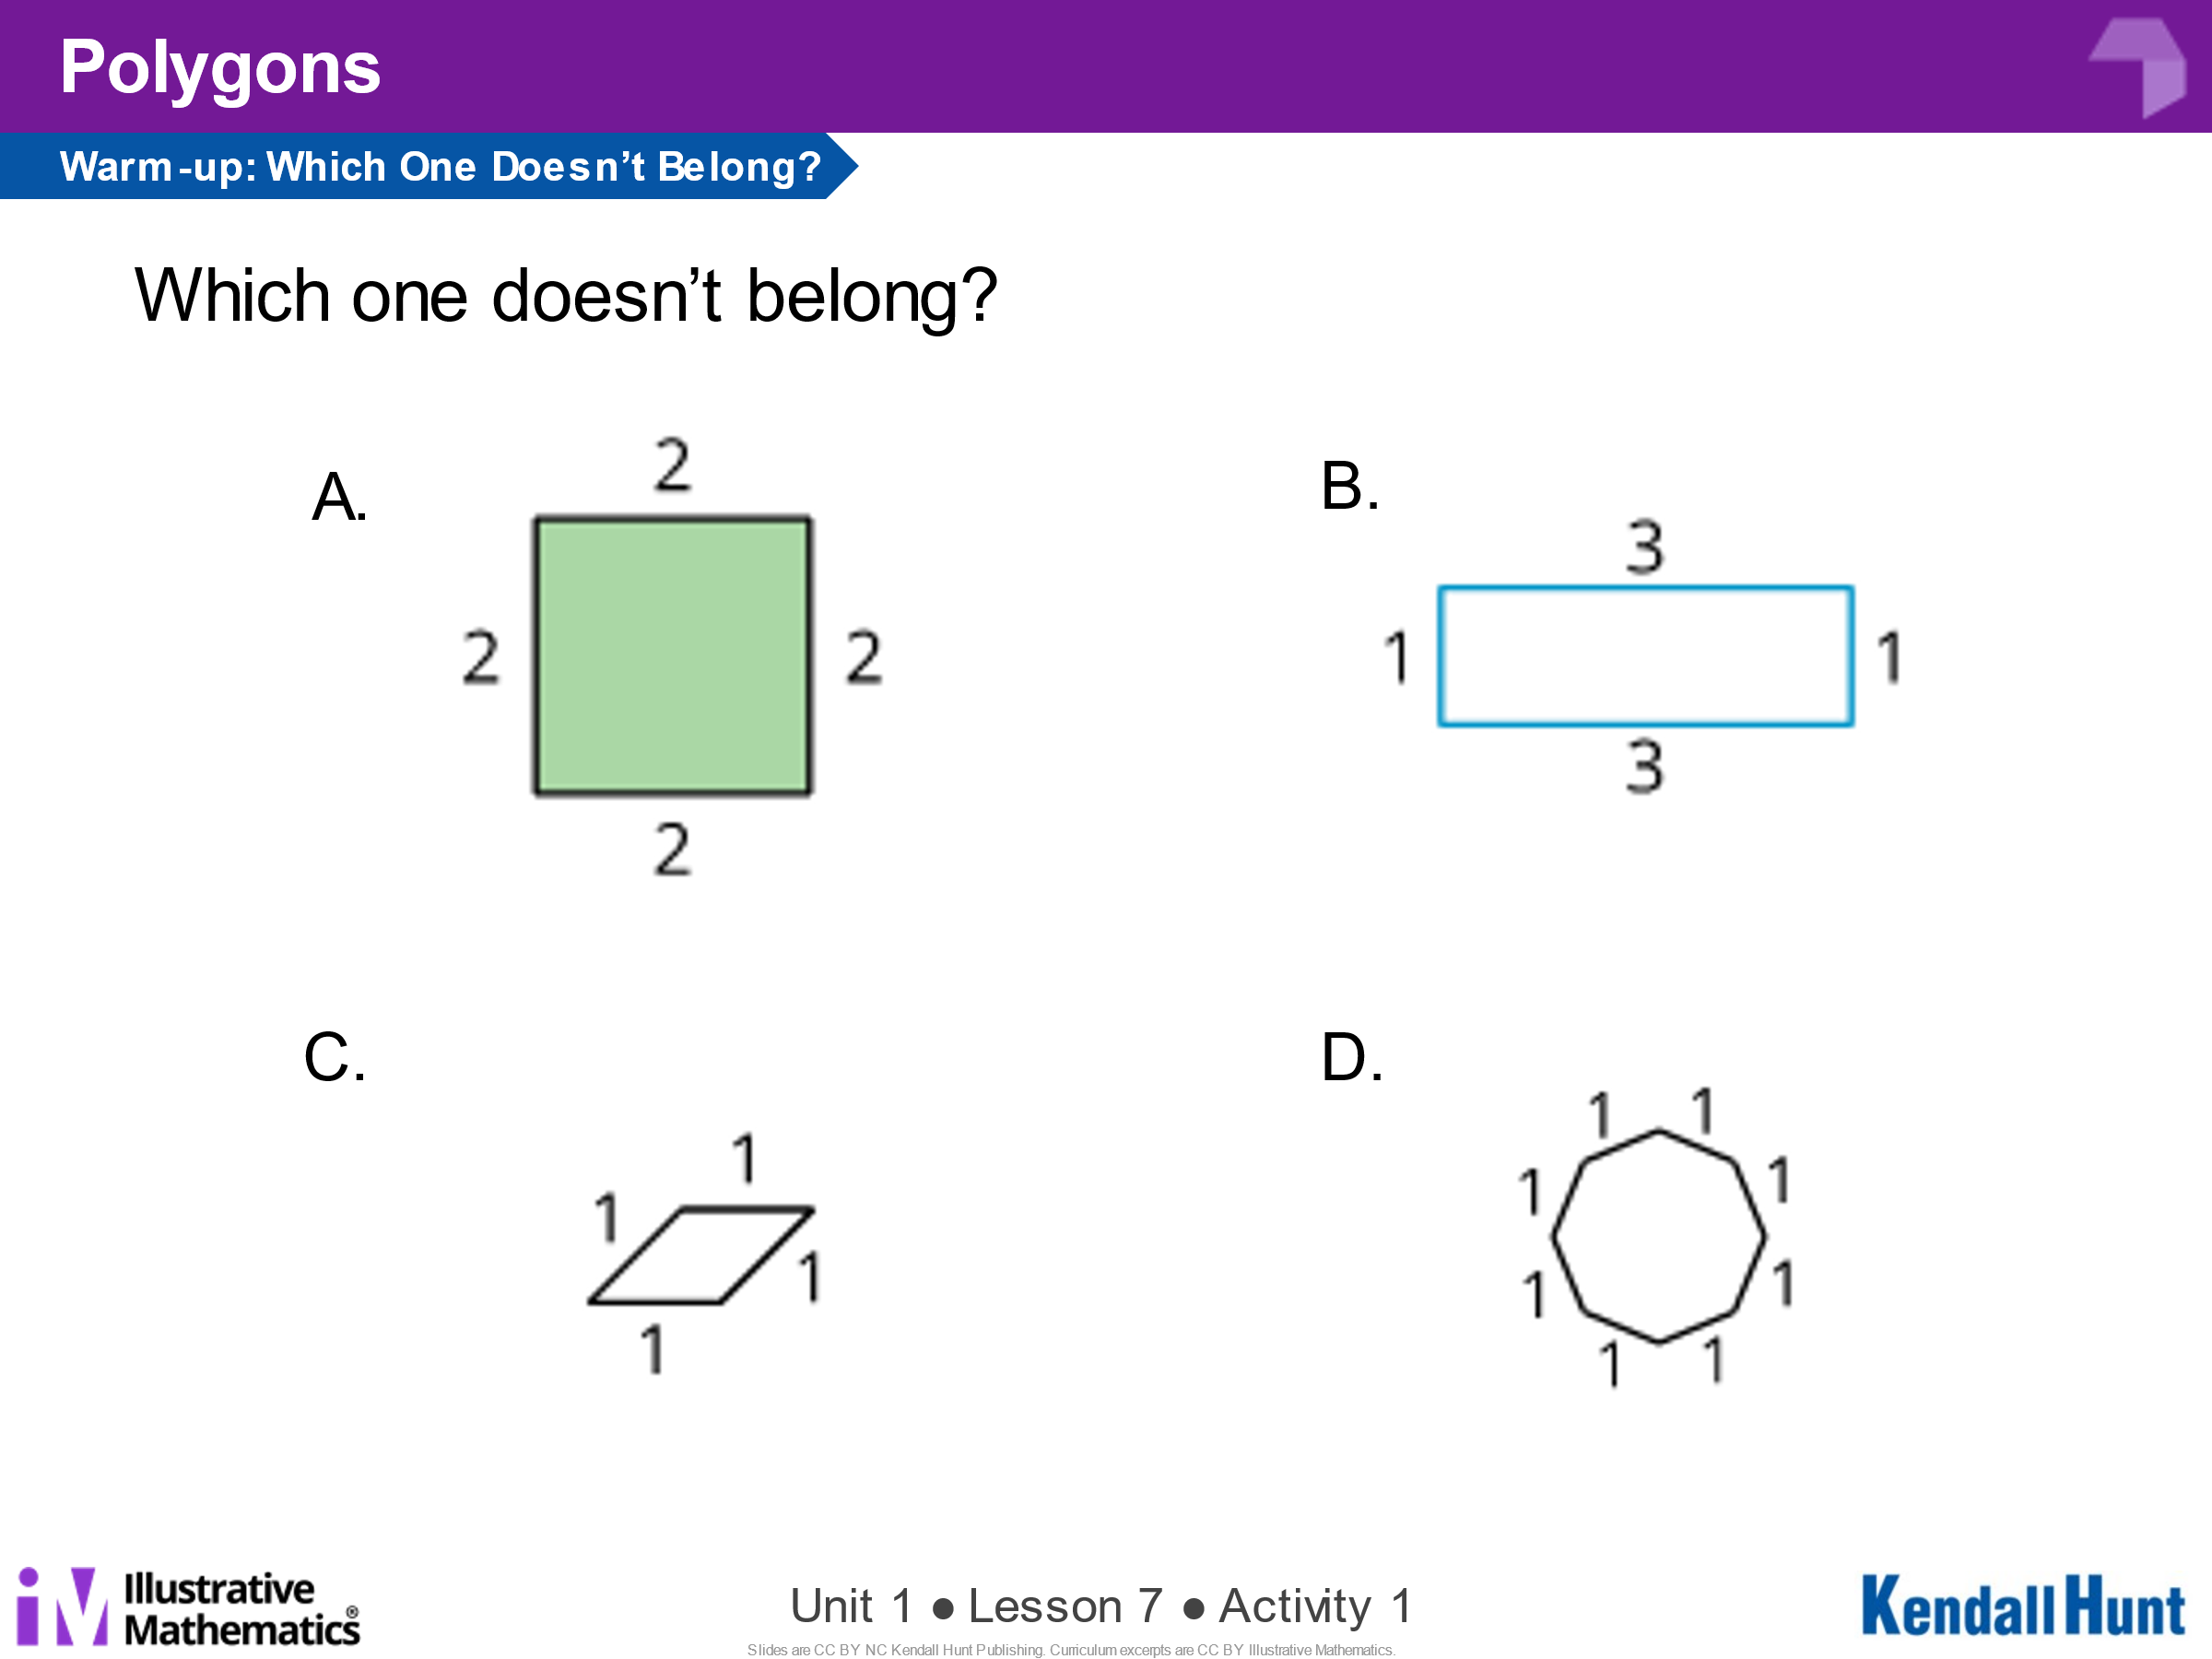
Say why you picked the one you did.
_______________________________
_______________________________
_______________________________
_______________________________
_______________________________
_______________________________
_______________________________
_______________________________

Definitions:
- Regular Polygon: ________________________________________________________________

______________________________________________________________________________

- Square: _______________________________________________________________________

______________________________________________________________________________

- Inscribed: _________________________________________________________________

______________________________________________________________________________

- How do you construct a circle using technology?

- What are some advantages of using technology to make geometric constructions?

- When do you think it is appropriate to use technology to make geometric constructions?

Construct a SQUARE where segment AB is one of the sides in the square.

Try to create each of these using the Constructions App. (Check them off as you create them)
- a perpendicular bisector of line segment ________
- an equilateral triangle ________
- a regular hexagon ________
- a square ________
- a square inscribed in a circle ________
- two congruent, right triangles that do not share a side ________

