Graded Classwork
LESSON
5-7
The Pythagorean Theorem
1. It is recommended that for a height of 2. Find x, the length of the weight-lifting
20 inches, a wheelchair ramp be incline bench. Round to the
19 feet long. What is the value of nearest tenth.
x to the nearest tenth?
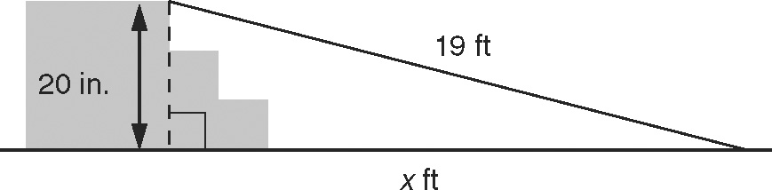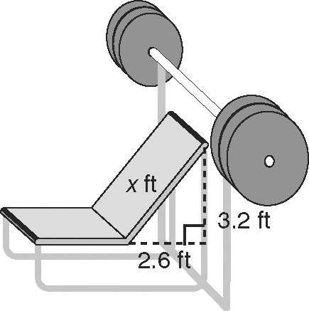

3. A ladder 15 feet from the base of a 4. In a wide-screen television, the ratio of
building reaches a window that is width to height is 16 : 9. What are the
35 feet high. What is the length of width and height of a television that has
the ladder to the nearest foot? a diagonal measure of 42 inches? Round
to the nearest tenth.

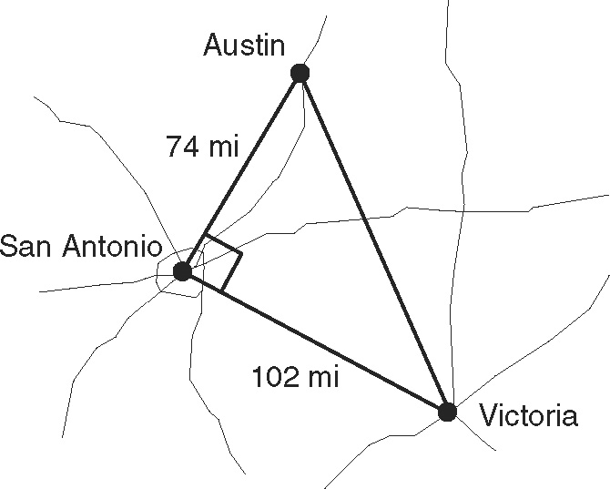
5. The distance from Austin to San Antonio
is about 74 miles, and the distance from
San Antonio to Victoria is about 102 miles.
Find the approximate distance from Austin
to Victoria.

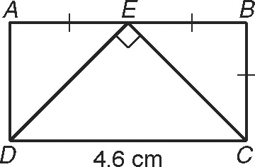
6. What is the approximate perimeter of
DEC if rectangle ABCD has a length
of 4.6 centimeters?

7. The legs of a right triangle measure 3x and 15. If the hypotenuse measures 3x + 3, what is the value of x?

