Name:_____________________________________ Math 163 Practice Test #3

1. What is the 4th term in the expansion of (x + y)7 ?
2. Expand the binomial (2x – 1)5 ?
3. What is the 5th term of the expansion of (2x + 3)8 ?
4. Given the functions: f(x) = -4x5 + 3x3 – 8x2 + 10 and g(x) = 6x5 + 4x4 – 8x3 + 2x2 – 4

Simplify (f + g)(x) and (f – g)(x).

1. Given the functions f(x) = 2x2 – 3x + 1, g(x) = 6x – 2, h(x) = x2 + 3

Simplify each using function operations and state the domain. (If not all real numbers)

1. (fg)(x) =
2. (f/g)(x) =
3. (f o g)(x) =
4. (g o h)(x) =
5. (h o h)(x) =
6. Find the inverse of the given functions:
7. f(x) = -6x + 3 b) g(x) = 2x2 - 8
8. State whether or not the functions are inverses of each other. (Show work)
9. , 
10. , 
11. Sketch the inverse of the functions shown:

a)



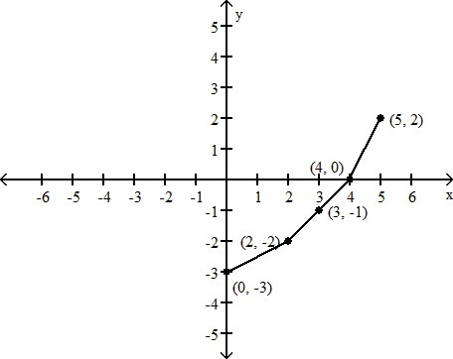 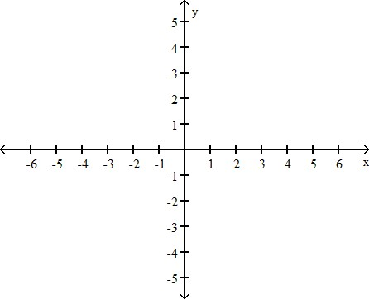



b)





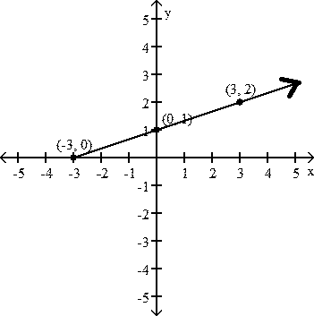 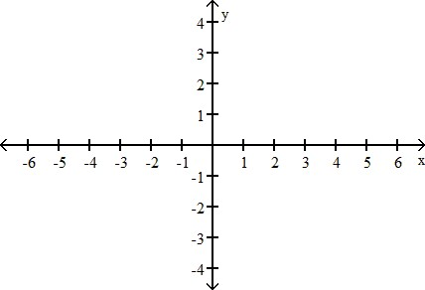

1. Sketch a graph of two functions one that is one-to-one and one that is NOT one-to one.

One-to-One **NOT** One-to-One

1. Expand the logarithm using the three “Laws” of logarithms
2. log2 (ab2)

1. log3 (x2/yz3)
2. ln
3. Write the expansion as a single logarithm: 3 log4 x + 2 log4 y – 4 log4 z
4. Solve each equation:
5. 
6. −10 + log3 (n + 3) = −10
7. −6 log3 (x − 3) = −24
8. log x + log 8 = 2
9. ln (4x + 1) − ln 3 = 5