

B



D



C



A



SEE END OF TEST

SEE END OF TEST



D



IQR = 80, 1.5(80) = 120 There are no outliers in this set

30 – 120 = -90

110 + 120 = 230

No it is below the median and is around the lower 25th percentile (Q1) but not very low.





Binompdf(20, .11, 2)



1 – Binompdf(10, .11, 0)



150(.11) = 16.5, around 16 or 17 people

A deck of cards has 3 blue, 4 black, and 6 purple cards. You pick 2 cards from the deck. Cards are not returned to the deck after they are picked.  
P(two blue cards in a row)

(3/13)(2/12) = 1/26

What is the probability of scoring a total of 18 when three fair dice are rolled? (Hint: the only way of getting a score of 18 is if the three dice shows a 6 each.

1/216

Two fair dice, one colored white and one colored red, are thrown. Find the probability that:

1. the score on the white die is 1 and red die is even.

1/12

1. the score on the white die is either 3 or 5 and the red die is odd.

1/6

Two sets of cards with a letter on each card as follows are placed into separate bags.   
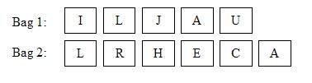  
Sara randomly picked one card from each bag.   
Find the probability that:

1. She picked the letters ‘J’ and ‘R’. 1/30
2. Both letters are vowels. 1/5

