Name ______________________________________ Date _____________
Unit 1: Visual Representations of Functions Review
1. Sketch and label each of the function families we discussed.

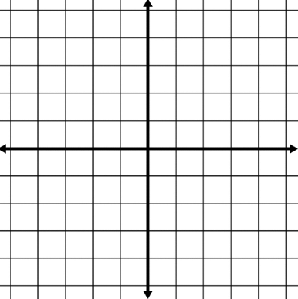
2. Identify the zeros of the following function.
Graph that function.
$f\left(x\right)=x^{2}(4x-3)(2x+1)$

3. Graph the following functions on the same coordinate plane.
$f\left(x\right)=4x-7$
$g\left(x\right)=(x-5)(x+3)$
$h\left(x\right)=x(x-4)(x+2)$

4. Use the function below to identify the following characteristics.
Even/Odd/Neither
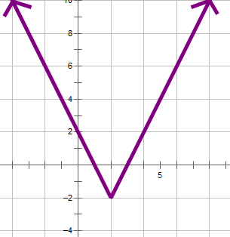
End Behavior

Asymptotes (horizontal/vertical)

Domain

Range

Intercepts (x/y)

5. Use the function below to identify the following characteristics.
Even/Odd/Neither
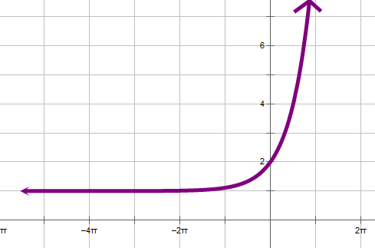
End Behavior

Asymptotes (horizontal/vertical)

Domain

Range

Intercepts (x/y)
6. Sketch an accurate graph of a function with one horizontal asymptote and a zero at x = 3.

7. Sketch an accurate graph of a function with even end behavior, 3 “turns”, and a y-intercept at -2.

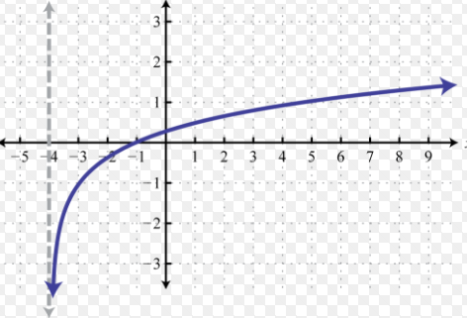
8. State the function family, asymptotes, and end-behavior of the given function graphs.
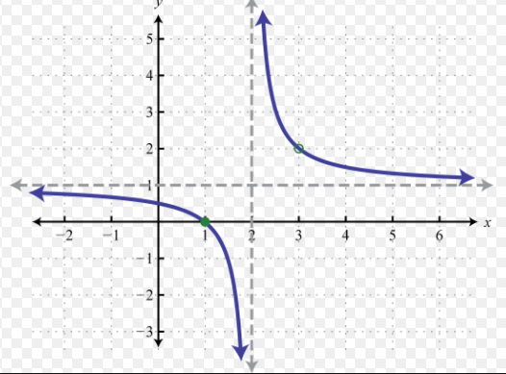

9. Average NBA’s Athlete’s Salary since 1980
Years since 1980 | 0 | 5 | 10 | 15 | 16 | 17 | 18
Salary (In thousands) | 170 | 325 | 750 | 1900 | 2000 | 2200 | 2600

Determine the function family to which the data above belongs and find the regression equation.

Use the equation found above to calculate the salary (in thousands) in 2005. Show your work!

10. Write the equation of a line that passes through (-2, 5) and (3, -7).

11. Fill in the table of values for the given exponential function. Graph that function.
Make sure to label your axes to show what increment you are counting by.
$y=5^{x}$
X | Y
-2
-1
0
1
2
3

